Internship Report
Electrical Department
Reliance Industries limited
Nagpur Manufacturing Unit
Mouda.
Siddharth Bhal
10-25 Jun, 2010

Preface

The purpose of this report is to explain what I did and learned during my internship period with the Reliance Industries Limited (RIL), Nagpur Manufacturing Division. The report is also a requirement for the partial fulfillment of the Reliance Industries Limited (RIL) internship program. The report focuses primarily on the assignments handled, working environment, successes and short comings that the intern did encounter when handling various tasks assigned to him by the supervisor.
Because the various parts of the report reflect the intern’s successes, observations and comments, it would be imperative that the recommendations are also given. Therefore the report contains my observations with their effect on me. It is hoped that this report would serve as a cardinal vehicle to the improvement of the internship program.
This also explains in brief the basics of various electrical equipments and principles encountered by me during the internship program.

Executive Summary
RIL,Nagpur Manufacturing Division is located in Nagpur, Maharashtra. It manufactures polyester filament yarn, dope-dyed specialty products of different ranges, fully drawn yarn and polyester chips.
The plant has facilities like housing for its employees, school, guest house and a Ganesha temple.
RIL - Nagpur Manufacturing Division is an ISO: 9001:2000 certified unit accredited by BVQI, along with certification for ISO14001: 2004 and OHSAS 18001:1999 as well.
Products Manufactured:
Polyester Filament Yarn (PFY) from PTA & MEG
DD Specialty product of different range
Fully Drawn Yarn
Polyester chips
Reliance invests significant amounts on R&D in the polyester sector. Reliance Technology Center, Reliance Testing Centre and Reliance Fibre Application Centre constantly develop and introduce innovative products for the textile industry. Reliance enjoys a portfolio of about 120 global patents in the polyester domain.
During Internship I studied the power distribution system adopted by the factory. I got the opportunity to learn different aspects of many electrical equipments used throughout to supply power to different parts of the factory. This internship helped me to improve in understanding Transformers, DC Machines, Power Grids, Circuit Breakers(SF₆), Isolators, Relays, Current Transformer, Capacitor Voltage Transformer(CVT), Invertors, Uninterruptable Power Supply(UPS) Systems, Frictions Rolls, Groove Roll etc.

Table of Contents

Preface 2
Executive Summary 3
Table of Contents 4
Overview of Reliance Industries Limited 5
132KV Switchyard Single Line Diagram 6
132KV Switchyard Working 7
6.6KV Switch Board Single Line Diagram 9
6.6KV Switch Board Working 10
Inverter 10
UPS 11
Internship Activities 12
Conclusion 13

Reliance Industries Limited

The Reliance Group is India's largest private sector enterprise, with businesses in the energy and materials value chain. Group's annual revenues are in excess of US$ 44 billion. The flagship company, Reliance Industries Limited, is a Fortune Global 500 company and is the largest private sector company in India.
Backward vertical integration has been the cornerstone of the evolution and growth of Reliance. Starting with textiles in the late seventies, Reliance pursued a strategy of backward vertical integration - in polyester, fibre intermediates, plastics, petrochemicals, petroleum refining and oil and gas exploration and production - to be fully integrated along the materials and energy value chain.
The Group's activities span exploration and production of oil and gas, petroleum refining and marketing, petrochemicals (polyester, fibre intermediates, plastics and chemicals), textiles, retail and special economic zones.
Reliance enjoys global leadership in its businesses, being the largest polyester yarn and fibre producer in the world and among the top five to ten producers in the world in major petrochemical products.
Its activities include oil and gas exploration and production, petroleum refining and marketing, petrochemicals (polyester, fiber intermediates, plastics, and chemicals), and textiles. Its exports reach nearly 100 countries across the globe, totaling US$7 billion annually.
Nagpur Manufacturing Division is located in Nagpur, Maharashtra. It manufactures polyester filament yarn, dope-dyed specialty products of different ranges, fully drawn yarn and polyester chips.
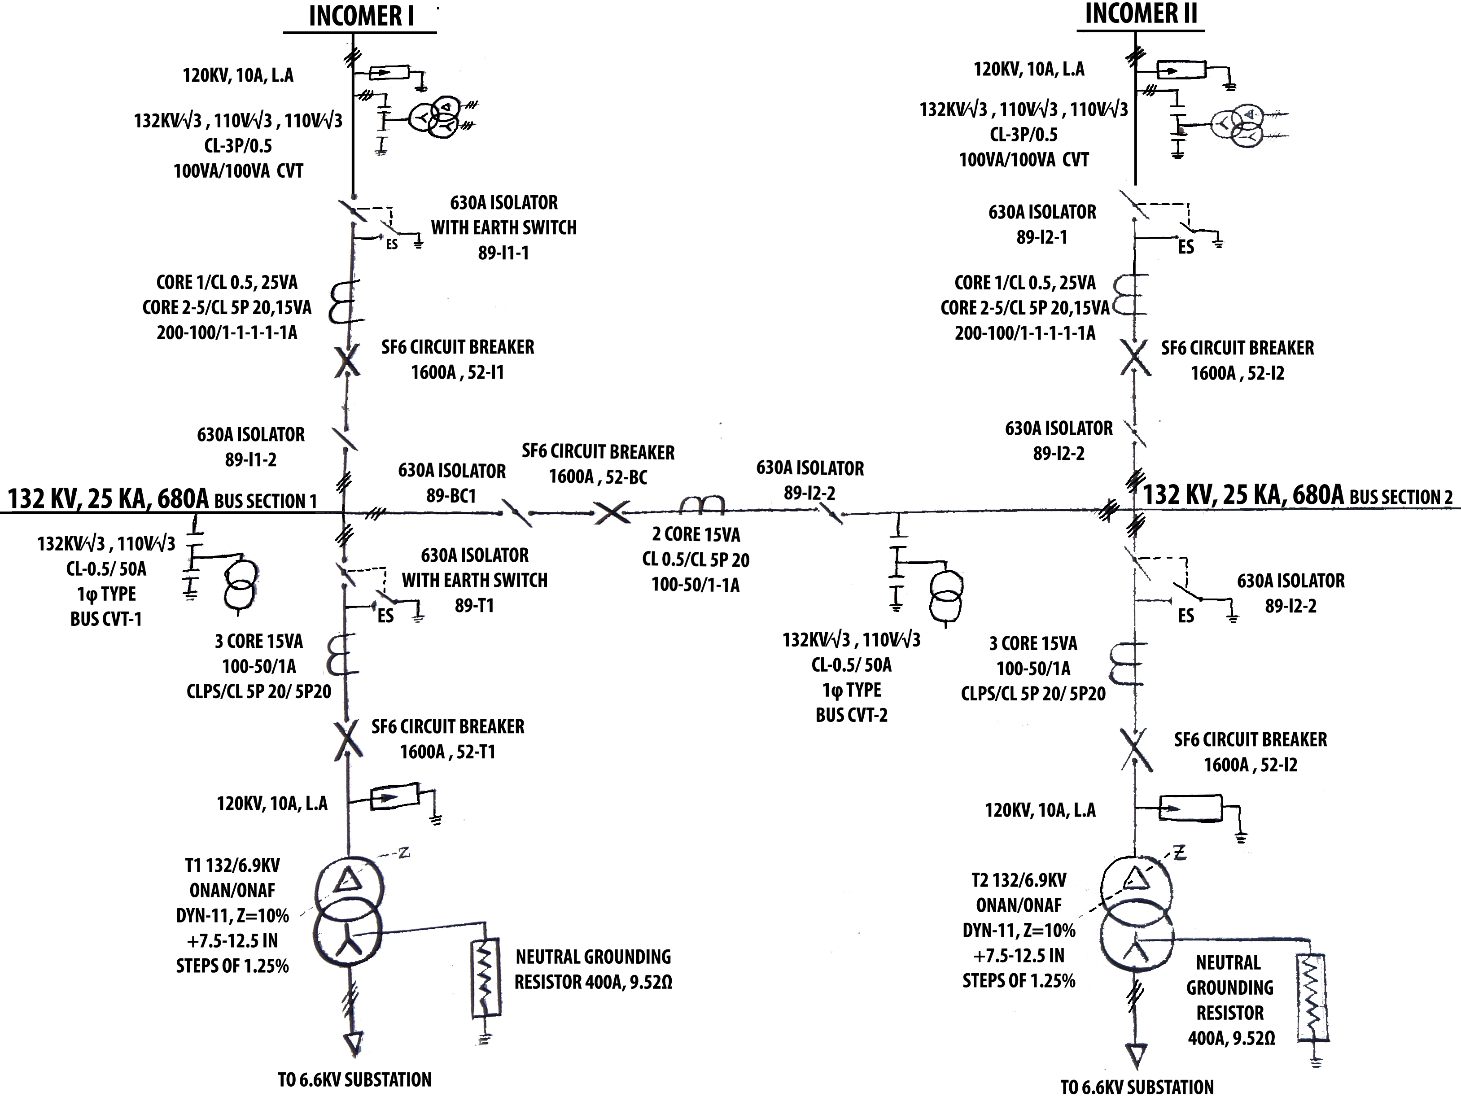
132KV Switchyard Single Line Diagram
132KV Switchyard Working
Maharashtra state electricity board (MSEB) supplies two lines of 132KV from two feeders reaching from Kanhan and Bhandara. The two incomers are connected in-between by a common bus. The utility of the bus is to maintain a continuous power supply even if power supply fails from any one incomer fails.
Incomers are connected to Lightning Arrestor (LA). It helps to prevent any damage to the circuit under lightning condition by providing direct earthing to the circuit and thus safeguarding further electrical equipments and instrument down the line.
Next a CVT (Capacitor Voltage Transformer) is connected for isolating the power circuit from control circuit. It steps down primary high voltage to secondary low voltage. Thus secondary voltage can be used as indication of primary voltage considering the CVT Ratio by connecting the output to protective relays which saves the circuit under over-voltage condition. CVT also helps to isolate the primary circuit from the secondary one. In this way it prevents any damage to cause in the secondary circuit due to fault in primary circuit.
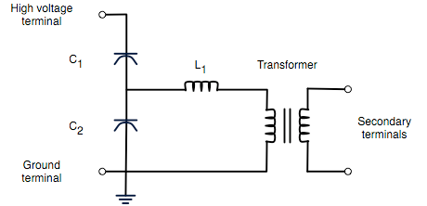
The circuit diagram for a simple capacitor voltage transformer

In its most basic form the device consists of three parts: two capacitors across which the transmission line signal is split, and a transformer to isolate and further step down the voltage for the protective relay. The device has four terminals: a terminal for connection to the high voltage signal, a ground terminal, and two secondary terminals which connect to the instrumentation or protective relay. A Potential transformer (PT) can also be used in place.
Isolator (Disconnector) is used to physically disconnect the circuit. As a precaution isolator should never be disconnected while the circuit is on load otherwise a heavy spark is bound to occur on high voltage lines. Therefore opening isolator is last step if we desire to cutoff the circuit.
Current Transformer (CT) is used for measurement of electric currents. When current in a circuit is too high to directly apply to measuring instruments, a current transformer is used to produces a reduced current accurately proportional to the current in the circuit, which can be conveniently connected to measuring and recording instruments. It also isolates the measuring instruments from what may be very high voltage in the monitored circuit.
A Circuit Breaker (CB) is an automatically-operated electrical switch designed to protect an electrical circuit from damage caused by overload or short circuit. Its basic function is to detect a fault condition and, by interrupting continuity, immediately discontinue electrical flow. Current interruption in a high-voltage circuit-breaker is obtained by separating two contacts in SF₆, having excellent dielectric and arc quenching properties.
Transformers are 132KV/6.9KV with delta to star connection manufactured by VOLTAMP. Earthing for secondary star connection is provided through 9.52 ohm resistor. Though rated secondary voltage is 6.9KV, but under load conditions and due to voltage regulation the secondary voltage come out to be ~6.6KV (for which many machines in the factory are designed to work upon).
Full load loss: 54KW Rating: 7.5/10MVA
No load loss: 12.3KW (ONAN/ONAF)
Frequency: 50Hz

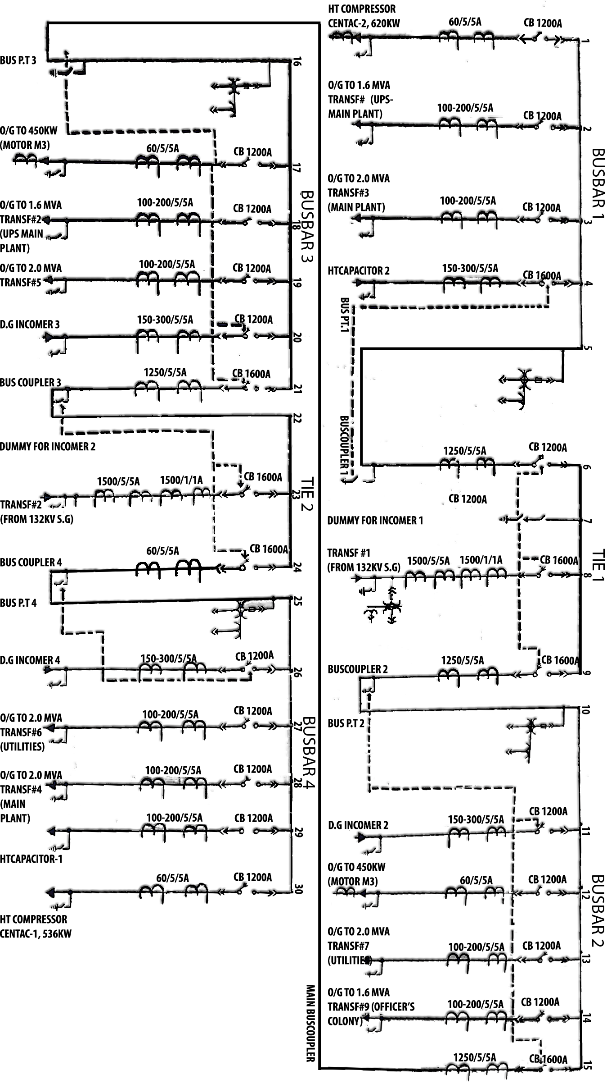
6.6KV Switch Board Single Line Diagram

6.6 KV Switch Board Working

The 132KV supply is converted to lower voltage of 6.6KV on secondary side. This 6.6KV is used to feed power to motors, capacitors, compressors rated to work on this voltage level. The incomer from T1 is fed to line no. 8 and 24 of TIE1 and TIE2 respectively. CT, PT and CB are used for safety and measuring purposes.
Bus couplers are used to connect busbars & tie with each other.
Bus PT is used to determine the voltage level in the bus and thus step-down this high voltage for the use of measuring instruments.
D.G Incomer 1&2 are used to supply the power in case of power failure from Diesel Generator (DG).
Motors and Compressors rated to work on 6.6KV are connected directly through 6.6KV substation.
A capacitor is connected to maintain a good power factor (near to unity) since most of the load is inductive in factory.
Other supply lines are fed to transformers (6.6KV/433V) which provide secondary output of 433V. This voltage level is required by large number of machines operating in the factory and is distributed through Power Control Centre (PCC) panels of individual transformers.

Inverters
An inverter is an electrical device that converts direct current (DC) to alternating current (AC); the converted AC can be obtained at any required voltage (smaller than supply voltage in case) and frequency. An inverter is essentially the opposite of a rectifier. Inverters are commonly used to supply AC power from DC sources such as batteries. One of the great utility of inverters can be deduced from the fact that to supply input of frequency other than 50Hz (usually in case of asynchronous motors) inverters were necessarily needed.

Rectifiers
A rectifier is an electrical device that converts alternating current (AC) to direct current (DC). Its function is just opposite of inverters.

Uninterruptable Power Supply (UPS)

An uninterruptible power supply (UPS) is an electrical device that provides emergency power to a load when the input power source fails. A UPS differs from other power system or standby generator in respect that it will provide instantaneous protection from input power interruptions.
The on-battery runtime of NELCO UPS installed in factory is ~20 minutes. During fault/power failure the supply is provided and in the mean time diesel generator is started with start-on time of 3 minutes.
Each module installed has capacity of 400KVA. Thus total capacity is 400*4*2=3200KVA.
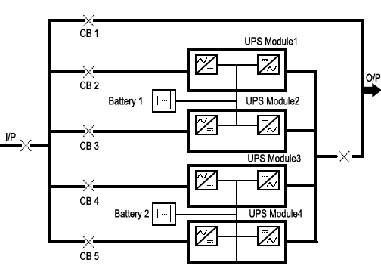
Configuration of UPS can be understood from figure present below:

Internship activities

- I visited 132KV power station which was novel experience for me. I understood how power is supplied to different substations present in nearby districts, villages and other factories.
- I also learned the distribution of power for household purposes as RIL, MOUDA has their own substation for distribution to their ‘officer’s colony’.
- I also learned the applications of inverters and important role of UPS in the power setup inside factory.
- I got the opportunity to examine various make and models of fuses, circuit breakers, current transformers. Thos helped me to get better understanding of these devices.
- Apart I observed many precautionary measures taken during working on the high voltage lines as there is no space for mistakes to occur.
- I understand the difference between synchronous motor and asynchronous motor. For asynchronous motors inverters were deploy which can provide any voltage between 0-400V and frequency between 0-400Hz.
- I learned the importance of uninterruptable supply. As being a polyester manufacturing unit, even a small break in power caused the thread to break and thus would decrease the quality of production.
- Measures taken in this respect were:
UPS
DG Generator
- Learned the importance of capacitor used for maintaining the unity power factor.
- Took a look at other motors operating in the industry to feel the scale on which work in done.
Conclusions

- Internship at RIL, Mouda helped me to develop a better understanding of industrial application of various electrical devices.
- It helped me to relate my theoretical concepts with practical applications thus establishing a critical link in between.
- I also understood how work is done on such a large scale.
- It helped me to realise the applications of various electrical equipments in the polymer industry.
- I also saw latest electrical instruments deployed by the factory, giving me the idea of latest machinery development.
- This internship showed me a view of professional life of the engineers working, which will help me to direct myself in better way.
- Also it helped me to make myself more disciplined as in factories no leniency is allowed for safety reasons.
- Finally I want to thank from deep of my heart to
  - JAGBIR SINGH
  - SUNIL SHINGNAPURKAR
  - UM RAO
for their continuous support and co-operation during whole course of my internship. This experience couldn’t have been enjoyable without them.

